**CHAPTER TWO: Exercise**

**Exercise 2.1: Using Ipconfig**

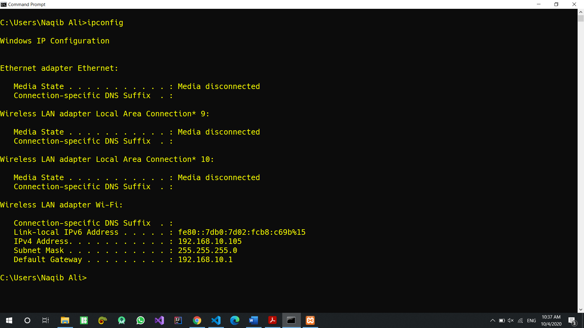

**Exercise 2.2: Using tracert**

Hops for [www.chuckeasttom.com](http://www.chuckeasttom.com) = 18

Hops for [www.whitehouse.gov](http://www.whitehouse.gov) = 7

Hops for [www.pearsonhighered.com](http://www.pearsonhighered.com) = 10

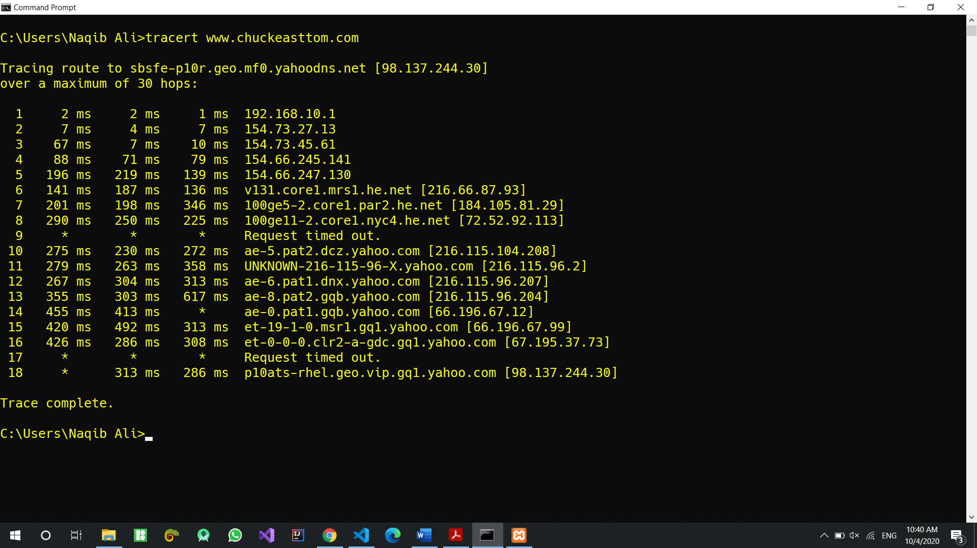

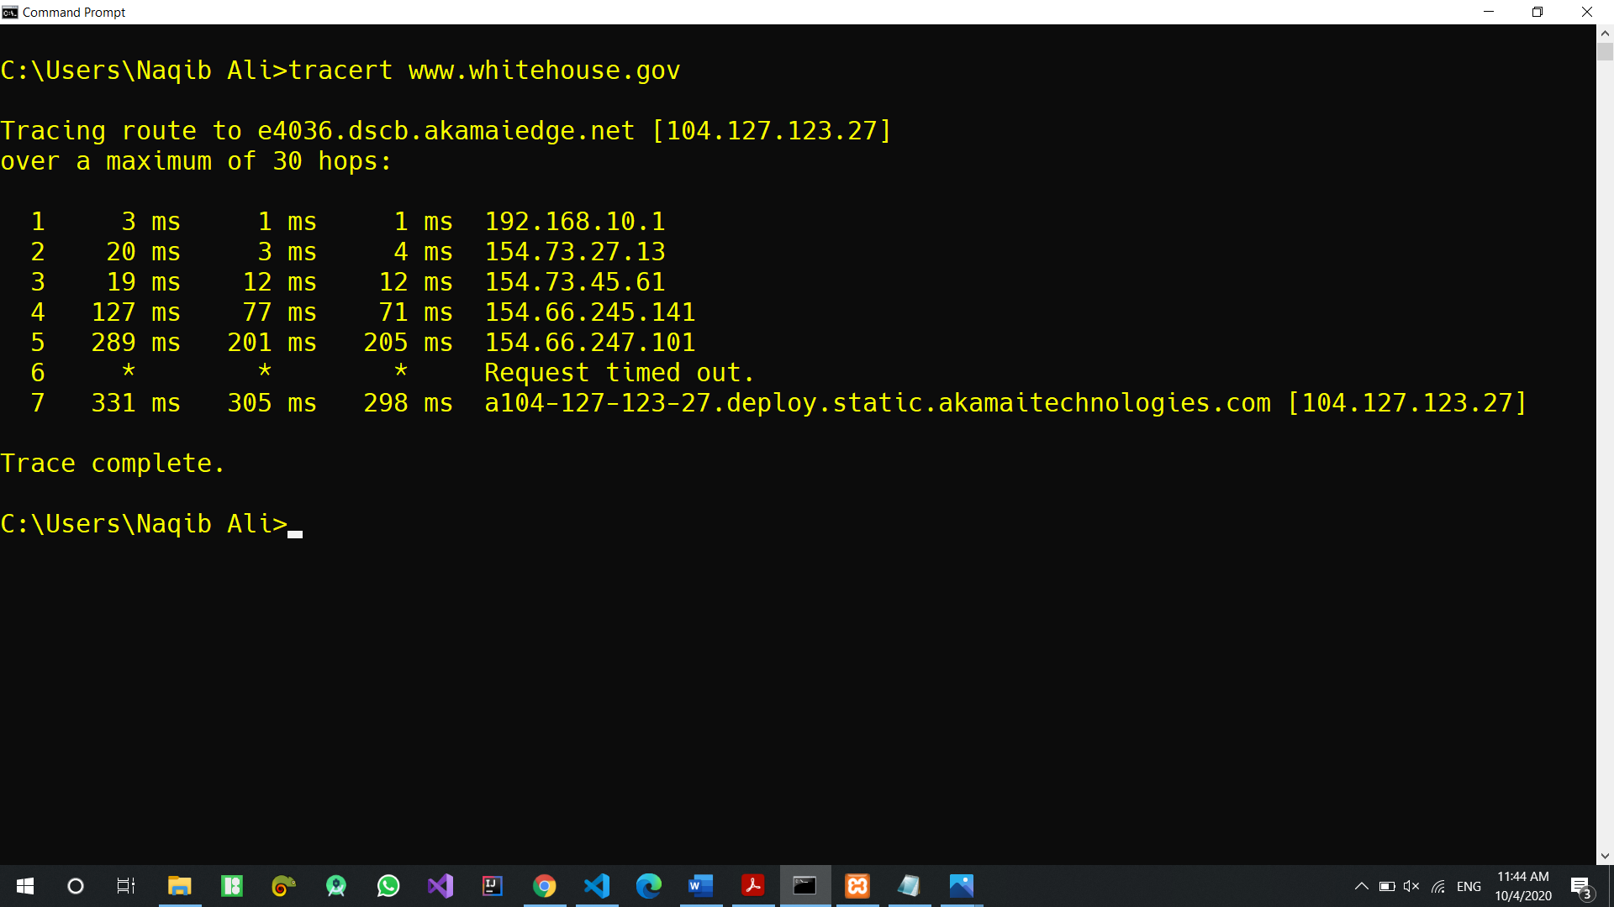

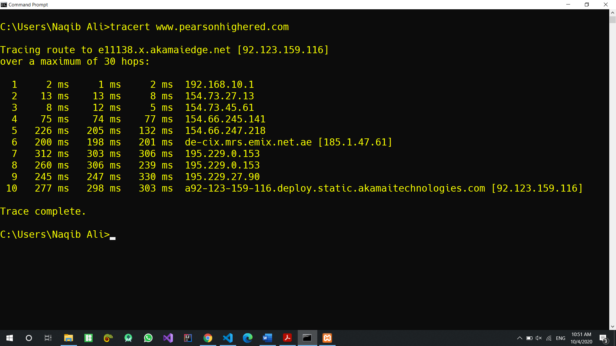

First four hops are almost same for all websites

**Exercise 2.3: Using NSLookup**

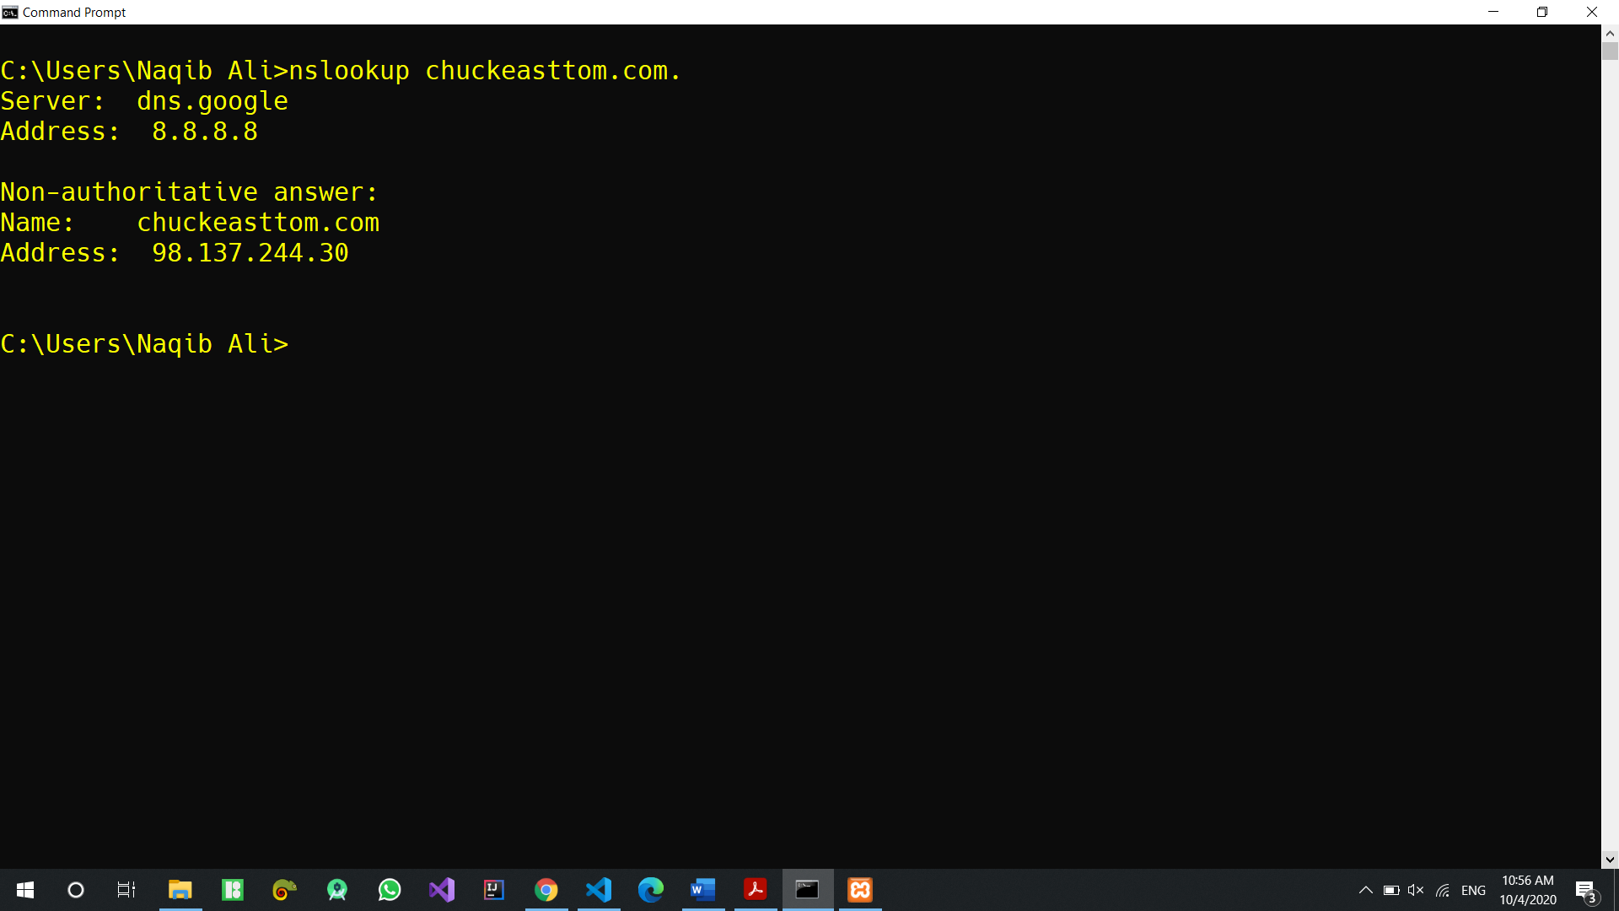

**Exercise 2.4: More About Ipconfig**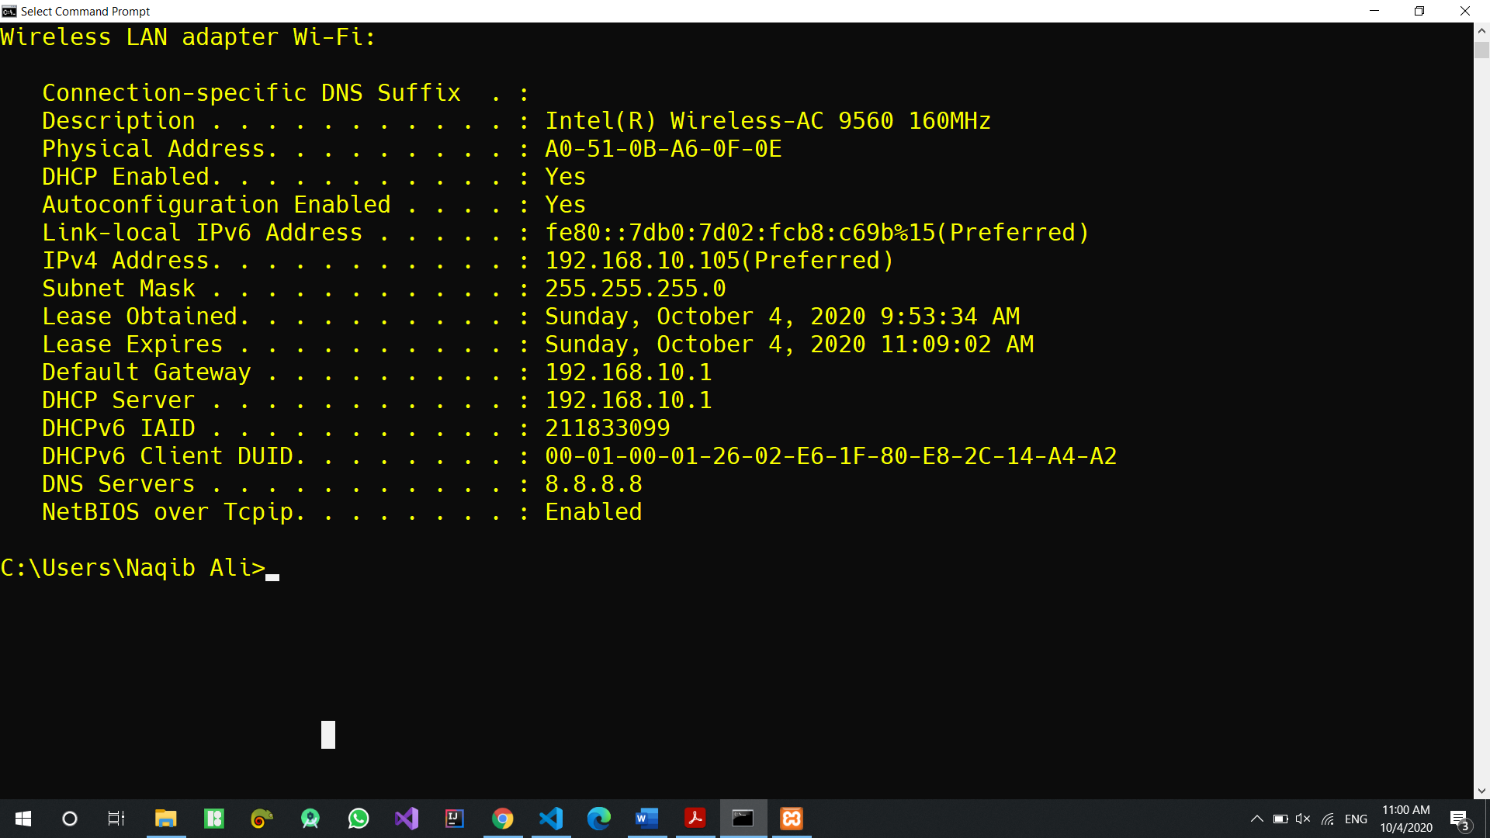

**Exercise 2.5: More About Ping**

🡪 ping -n 2 www.chuckeasttom.com

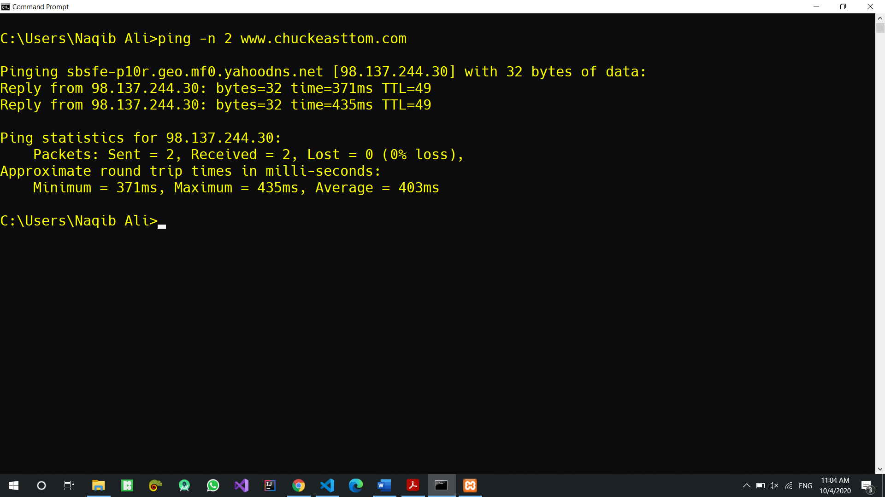

🡪 ping -n 7 www.chuckeasttom.com